# Part 1

Firstly, testing what changing the damping ratio (ζ) from 0 to 1 does to a general second order system, defined as:

( $G\left(s\right)=\frac{Kω_{n}^{2}}{s^{2}+2ζω_{n}s+ω_{n}^{2}}$ Where K=1; ωn=2 rad/s.

The following Figures Show the respective step responses for chosen damping ratios as well as the systems poles.

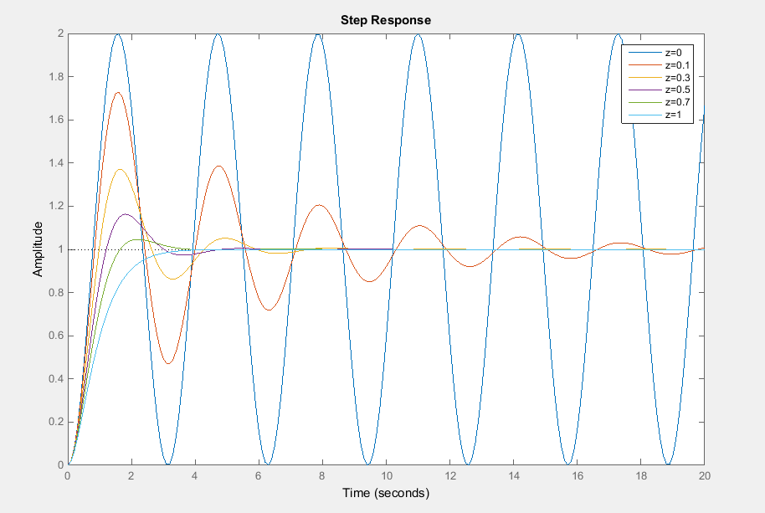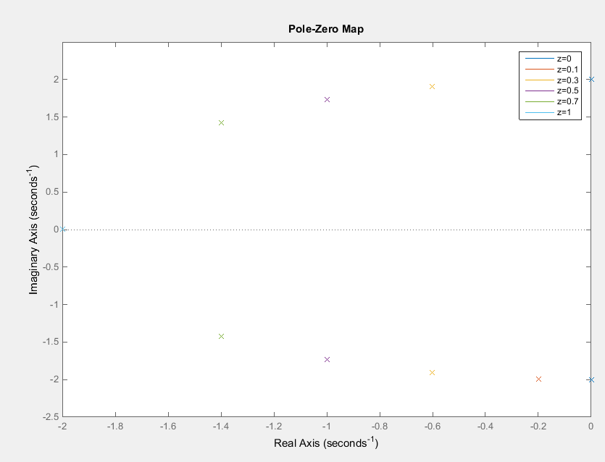

The resulting performance parameters can be found in the following table.

|  |  |  |  |  |
| --- | --- | --- | --- | --- |
| Damping Ratio | Settling Time (s) | Rise Time (s) | % Overshoot (%) | Frequency of Oscillation (rad/s) |
| 0 | N/A | N/A | 100 | 2 |
| 0.1 | 19.2 | 0.556 | 72.9 | 1.99 |
| 0.3 | 5.62 | 0.664 | 37.2 | 1.91 |
| 0.5 | 4.04 | 0.824 | 16.3 | 1.73 |
| 0.7 | 2.99 | 1.07 | 4.6 | 1.43 |
| 1 | 2.92 | 1.68 | 0 | 0 |

In analysing these results it is clear that by increasing the damping ratio, the systems ‘ripple’ is reduced. This means that the Overshoot of the system, the frequency of the oscillations, as well as the settling time are drastically reduced as the damping ratio is increased towards 1. While this is true, it takes a longer amount of time to get to the desired output level in the first place. This is seen in an increased rise time as the damping ratio is increased. At a damping ratio of one, there are no ripples present, and this is known as a critically damped case. The poles of the system while critically damped exist as only one pole on the negative real axis. In contrast, when the damping ratio is zero this system is undamped and the poles exist on the imaginary axis. As seen in the step response graph above, this undamped case does not reach a steady output, however it oscillates indefinitely instead.

# Part 2

For the following system: $$G\left(s\right)=\frac{K}{s^{2}+16s+K}$$

Design the parameter ‘K’ such that: $$\%OS=4.4; T_{s}<1.43s$$

Recall the formula

$$\%OS=e^{-\left(\frac{ζπ}{\sqrt{1-ζ^{2}}}\right)}$$

Rearranging givesecall the formula..stem:, this undamped case does not reach a steady output, however it oscillates ginary axis. As seen in the

Recall the general second order system form

$$G\left(s\right)=\frac{Kω_{n}^{2}}{s^{2}+2ζω_{n}s+ω_{n}^{2}}$$

Equating coefficients givesecall the formula..

Using this value for K creates the system equation: $$G\left(s\right)=\frac{128.76}{s^{2}+16s+128.76}$$

This gives the following step response and pole map:

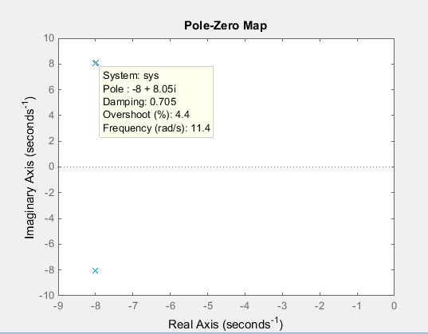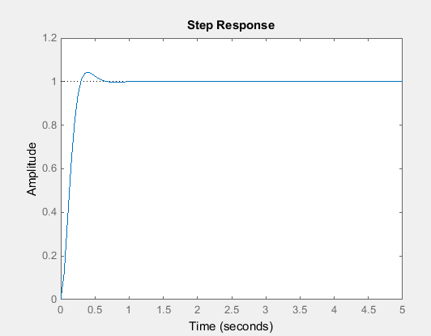

The performance parameters are as follows $$T_{s}=\frac{4}{ζω_{n}} \\ T_{s}≈0.5s \\ T_{s}=0.527 \\ T_{R}=0.195 \\ \%OS=4.4 \\ ω_{d}=8.05$$

Here it is clear that the required system of

$$\%OS=4.4; T_{s}<1.43s$$

Has been met with a K value of 128.76. This can be confirmed using the inbuilt Simulink software. These results are below.

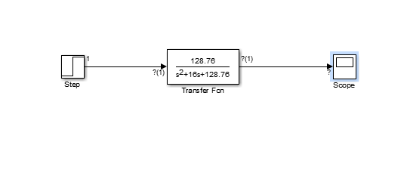

Scope output after 1s step input:

